

**Taprisiot Application User Manual**

|  |  |
| --- | --- |
| Abstract | This documents is the user manual of the ConoscopeDemo application |
| Version | 0.4 |
| Status | Draft |
| Date | 2020/11/18 |

Revision history

|  |  |  |
| --- | --- | --- |
| Version | Date | Content |
| 0.1 | 2020/06/03 | Initial version |
| 0.2 | 2020/06/25 | Add “log file” chapter |
| 0.3 | 2020/07/01 | Add export file naming options Add ROI Add AutoExposure Measurement Area Add AutoExposure level and exposure time thresholds Add CaptureSequence SaveCapture option Add ConvertRaw feature |
|  | 2020/07/02 | Add AE exposure time granularity |
|  | 2020/07/06 | Add <AeExpoGran> tag in ExportFormat name |
| 0.4 | 2020/11/18 | Add streaming options |

|  |  |
| --- | --- |
|  | ELDIM 1185 Rue d’Epron (Ancienne) 14200 Hérouville Saint-Clair France |
|  | Copyright © 2020 All rights reserved. Printed in France. |
|  | ELDIM, the ELDIM logo and other product names referenced herein are trademarks of ELDIM.  Other product names, designations, logos, and symbols are trademarks or registered trademarks of their respective owners. |
|  | NO WARRANTY. The technical documentation is being delivered to you AS-IS and ELDIM makes no warranty as to its accuracy or use. Any use of the technical documentation or the information contained therein is at the risk of the user. Documentation may include technical or other inaccuracies or typographical errors. ELDIM reserves the right to make changes without prior notice. |
|  | ELDIM considers information included in this documentation as Confidential Information. The access and use of this confidential information are subject to the terms and conditions of the Software license agreement, with which you agree to comply.  This documentation cannot be reproduced in any way without the prior agreement and written permission of ELDIM. |

Table of contents

1 Introduction 6

2 Install 6

2.1 Requirement 6

2.2 Application 6

2.3 User interface 7

3 Application version 7

4 Calibration Data 8

4.1 Manually 9

4.2 Download Calibration data from Taprisiot device 10

4.2.1 open 10

4.2.2 Read data 10

4.2.3 Read Status 10

5 Capturing an image 11

5.1 Configuring capture folder 11

5.2 Open the device 11

5.3 Setup 11

5.4 Image Capture 11

5.4.1 Measure command 11

5.4.2 MeasureAE command 11

5.4.3 Measure output 13

5.5 Export Capture 14

5.5.1 Export Capture options: 14

5.5.2 Raw Data Format 15

5.5.3 Processed Data Format 16

5.6 Display Capture 16

5.7 Next Step 16

6 Closing the device / Reset 17

7 Streaming 17

7.1 Usage 17

7.2 Display options: 17

8 Capture Sequence 18

8.1 Description 18

8.2 Command 18

8.3 Result 20

9 Processing captured data 21

9.1 Processing RawData 21

9.2 Processing CaptureSequence 21

10 Log file 22

10.1 Introduction 22

10.2 Configuration 22

10.3 Log file 22

# Introduction

Conoscope Application drives the taprisiot device.

The application handles following features:

* Calibration data
* Taprisiot configuration: temperature and filter selection
* Capture: with specific exposure time or auto exposure option
* Export data: Raw Data or Processed data
* Capture Sequence: Capture required images to generate X, Y, Z images

# Install

## Requirement

Euresys drivers to drive the Frame Grabber: coaxlink-win10-x86_64-11.0.3.82.exe  
Once install, launch GenICam browser. The application may request to update frame grabber firmware.  
Please select Coaxlink Quad G2 (2 camera), update firmware. Once done shut down and unplug the PC to be sure the frame grabber board is properly switched off.

## Application

The application is **ConoscopeDemo.exe**. The folder contains all required dependencies.  
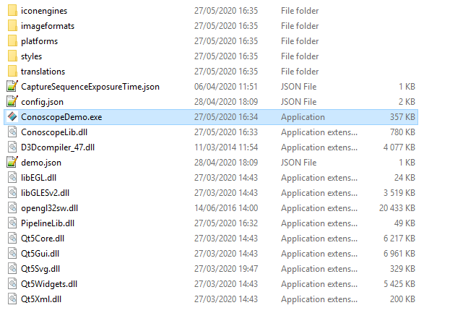

## User interface

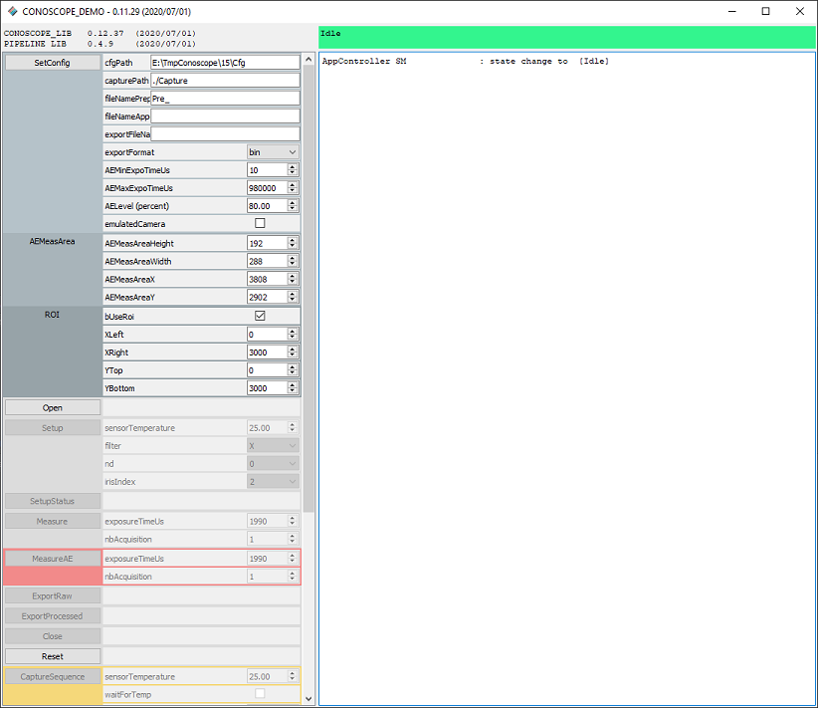

Warning:  
When launching the application, it might be possible that an error pops-up indicating that a dll is missing.  
Please install vcredist_x64.exe and/or vc_redist.x64.exe

# Application version

The application version and libraries version are indicated on the interface:

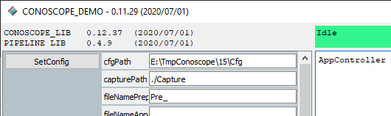

# Calibration Data

To run properly, the application must access calibration data of the Taprisiot.  
The folder where the calibration data are stored can be modified using SetConfig command:  
set path in **cfgPath** and press **SetConfig**  
  


Note: It is only possible to change the Calibration data folder after application start-up. Once Taprisiot is open, the folder can not be changed any more.

Calibration Data folder is populated by 2 ways:

* Manually. The user has calibration data and can copy it in the appropriate folder
* From Taprisiot: Data are stored in the memory of the Taprisiot and can be retrieved.

## Manually

Copy calibration data into the folder.   
remark: the subfolder matches with the camera SN (not the serial number of the taprisiot)   
To know the camera SN, press **Open** command. The Camera SN is displayed in the log.  
  
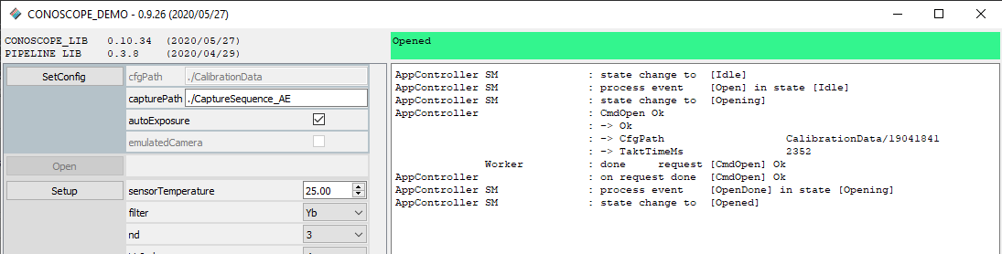  
  
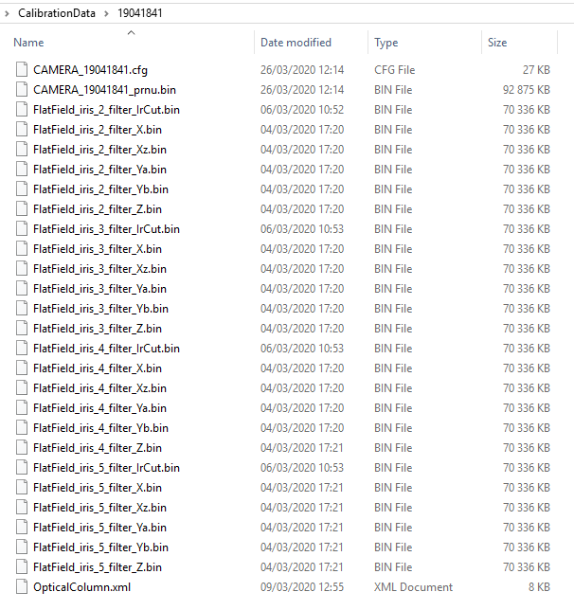

## Download Calibration data from Taprisiot device

calibration data is stored in the camera. It is possible to populate the folder with those values.  
**Remark**: This upload takes a lot of time (around 30 minutes)

### open

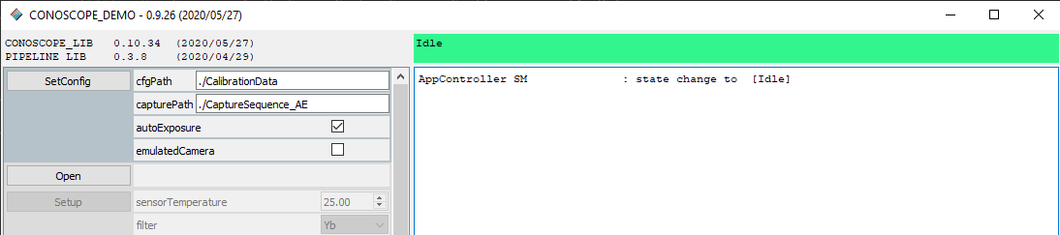

### Read data

Launch read using **CfgFileRead command**





### Read Status

Then regularly check Cfg with **CfgFileStatus** command until the process is complete.

# Capturing an image

## Configuring capture folder

When an image is captured, it is stored in a specific folder.  
Change the path in **capturePath** and press **SetConfig**

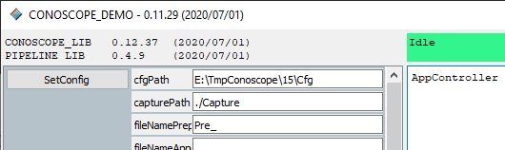

## Open the device

Initially Taprisiot is in **Idle** state.  
Press **Open** to bring the device in opened state.  
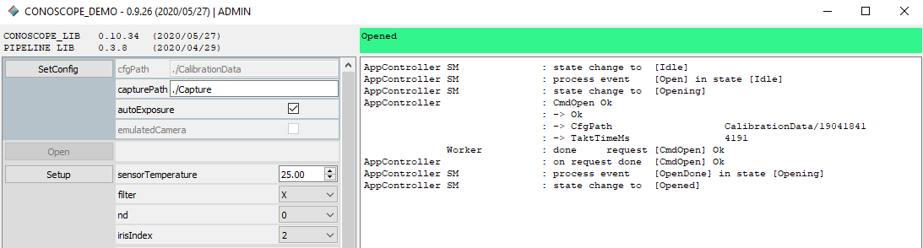

## Setup

Once opened, it is possible to setup the device

* Targeted temperature: the device will be regulated at this temperature
* Filter: BK7, Mirror, X, Xz, Ya, Yb, Z, IrCut
* Nd filter: density 0, 1, 2, 3, 4
* Iris: aperture: 2mm, 3mm, 4mm, 5mm. **Aperture must be changed manually**.

Press **Setup** to go in ready state

Current configuration can be retrieved with **SetupStatus** command

## Image Capture

### Measure command

**Measure** command will capture the image at the specified ExposureTime

### MeasureAE command

**MeasureAE** will capture the image after an AutoExposure sequence.

During MeasureAE processing, it is possible to know the status of the processing (**MeasureAEStatus**) and to stop the processing (**MeasureAECancel**)

MeasureAE command works with several iterations and will take more time than Measure command.

During the algorithm, an image is captured and processed.

The brightest pixel of the measurement area is measured, and the exposure time is tuned so this value matches a specified level of saturation. By default, the exposure time is tuned so the return value is 80% of saturation.

Measure AE Parameters:

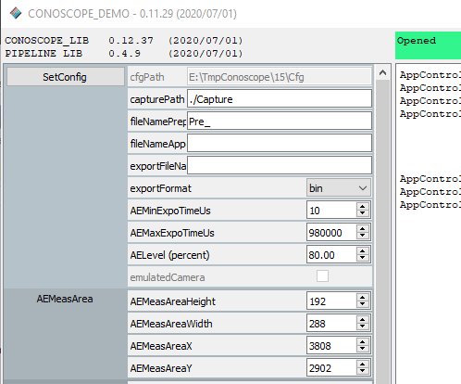

|  |  |
| --- | --- |
| Measurement Area | Defines the area where the measurement is done. note: the bigger the area is, the slower the algorithm is. |
|  | AEMeasAreaHeight [0, 6004] AEMeasAreaWidth [0, 7920] AEMeasAreaX [0, 7920] AEMeasAreaY [0, 6004]  Set All parameters to 0 to disable |
| Level | Defines the target of the algorithm. If Level is set to 80%, the exposure time is calculated so the brightest pixel of the measurement area is 80% of the saturation |
|  | AELevel (percent) |
| Threshold | Boundary in the exposure time (in micro seconds) |
|  | AEMinExpoTimeUs AEMaxExpoTimeUs |
| Granularity | Defines the granularity of the Exposure Time calculated by the algorithm. AEExpoTimeGranularityUs |

### Measure output

Measure Commands hold data internally.  
To store capture, use command **ExportRaw** or **ExportProcessed**.  
To display capture, use **DisplayRaw** or **DisplayProcessed**.

## Export Capture

From state MeasureDone, use Commands **ExportRaw** and **ExportProcessed** to store capture in binary format. Those commands do not perform a capture (Measure commands does, see previous chapter).

### Export Capture options:

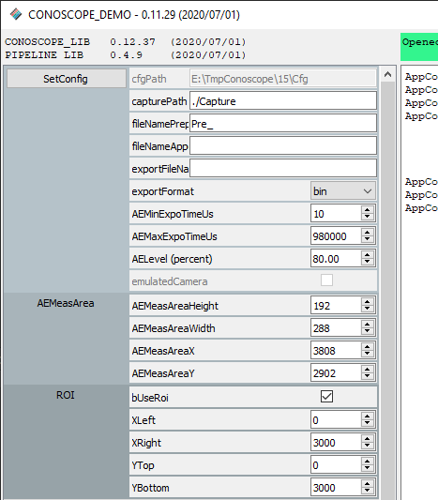

|  |  |
| --- | --- |
| capturePath | Folder where capture are exported |
| ROI | Defines the Region of interest of the exported image. (this apply only on processed capture)   0 XLeft XRight   0 +---+------------+---+   | |  YTop + ++++++++++++++ |   | ++++++++++++++ |   | ++++++++++++++ |   | ++++++++++++++ |  YBot + ++++++++++++++ |   | |   +--------------------+   Each value in range [0, 6001] |
| fileNamePrepend | Add a string the beginning of the exported file name |
| fileNameAppend | Append a string at the end of the exported file name |
| ExportFormat | Specify the format of the exported file name |
|  | <TimeStamp>  <Filter>  <Nd>  <Iris>  <ExpoTime>  <NbAcq>  <Height>  <Width>  <SatFlag>  <SatLevel>  <AeExpoGran> |
|  | default format  <TimeStamp>_filt_<Filter>_nd_<Nd>_iris_<Iris> |

### Raw Data Format

A capture is .bin file associated to a .json file containing information about the configuration of the device.  
A binary file can be opened using ImageJ

File > Import > Raw   
 Image type : 16 bits unsigned  
 Width : 7920  
 Height: 6004  
 Little endian byte order

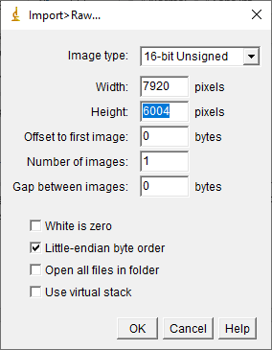

### Processed Data Format

Image processing:  
 Bias compensation  
 Sensor defect correction  
 Sensor PRNU correction  
 Linearisation (depends on Setup configuration)  
 FlatField (depends on Setup configuration)

File > Import > Raw   
 Image type : 16 bits signed  
 Width : 6001  
 Height: 6001  
 Little endian byte order

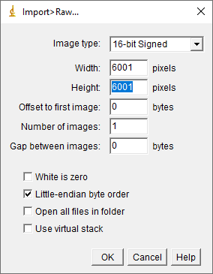

## Display Capture

**DisplayRaw** and **DisplayProcessed** allow to display the image captured with Measure command

Those commands do not perform a capture

## Next Step

Once a capture has been done, it is possible Measure again or to Setup and Measure

# Closing the device / Reset

In any state, the device can be closed or reset.  
Reset command will perform a power sequence on the Taprisiot (it takes about 2 minutes)

# Streaming

## Usage

When the device is in Ready state (after a **Setup** command). It is possible to display stream by pressing **DisplayStream**.

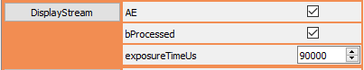

Streaming options: AutoExposure: AE parameters are set with SetOption command   
 bProcessed: Capture data are processed.   
 By default, only defect pixels are removed.  
 Configuration can be changed in DisplayStreamOption.json file

## Display options:

Zoom use the mouse wheel.   
Cursors right click on the image and select the option  
  
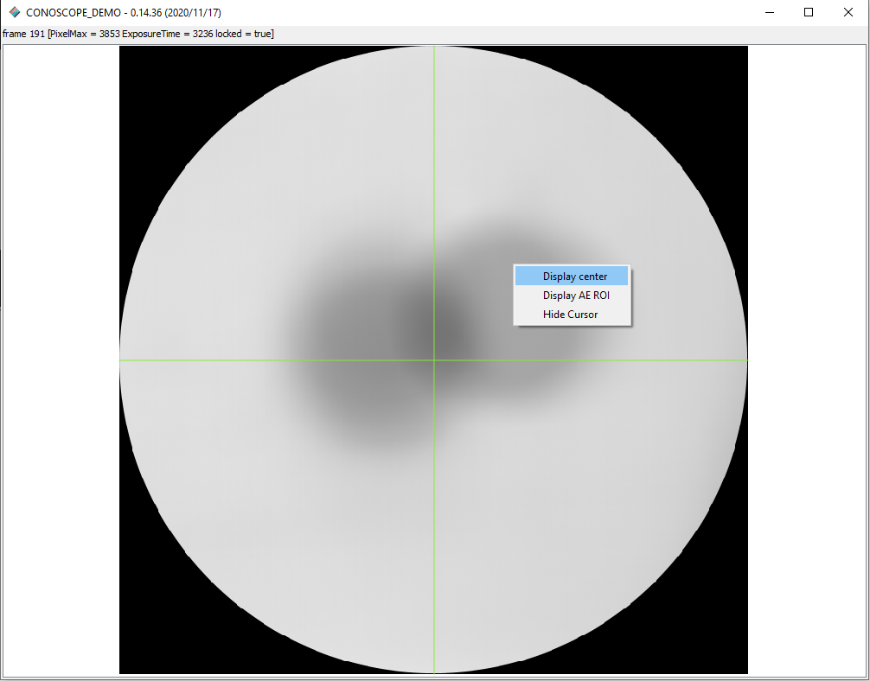

# Capture Sequence

## Description

Capture sequence captures necessary images to generate X, Y, Z images.  
5 capture are used:  
 - filter X  
 - filter Xz  
 - filter Ya  
 - filter Yb  
 - filter Z

## Command

Command **CaptureSequence** can be called from **Opened** state.

Parameters:  
 sensorTemperature: Target temperature for the Taprisiot  
 waitForTemp: The sequence waits till the target temperature is reached  
 nd: Setup the ND filter value  
 iris: Indicate the iris installed on the Taprisiot  
 exposure time: option 1: manual exposure, all captures are done   
 with the same exposure time  
 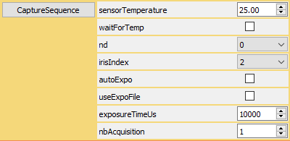  
 option 2: exposure time of each capture is defined in   
 CaptureSequenceExposureTime.json  
 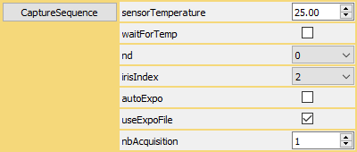  
 option 3: AutoExposure  
 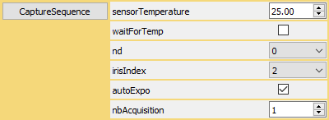

CaptureSequenceExposureTime.json the exposure time for each filter and is in the application directory

{  
 "ExposureTimeUs": {  
 "Filter_X": 10000,  
 "Filter_Xz": 10000,  
 "Filter_Ya": 10000,  
 "Filter_Yb": 10000,  
 "Filter_Z": 10000  
 }  
 }

Once the processing is started, it is possible to cancel it with **CaptureSequenceCancel** command

## Result

Once the process is done, X, Y, Z images can be found in capture folder (SetConfig)

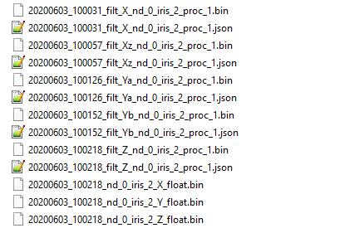

Note: If bSaveCaptures is checked, all intermediate captures are stored. Then, they can be processed latter.

Images can be opened with ImageJ

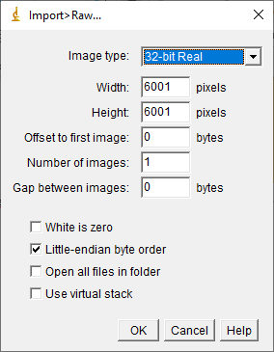

# Processing captured data

It is possible to process raw data already captured.  
From Idle state, set **emulatedCamera** option in **SetConfig** command (press SetConfig button to set)

## Processing RawData

Follow the steps described in chapter “Capturing an image”.  
Parameter for **Measure** command is the path of the bin capture to process.  
(note the associated json file must be present)

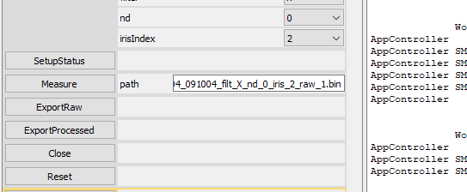

Then **ExportProcessed** command will generate the processed image using the calibration data.

## Processing CaptureSequence

Capture paths to be processed are defined in CaptureSequenceCaptures.json (in the application folder)

{  
 "FilePath": {  
 "Filter_X": "capture_X.bin",  
 "Filter_Xz": "capture_Xz.bin",  
 "Filter_Ya": "capture_Ya.bin",  
 "Filter_Yb": "capture_Yb.bin",  
 "Filter_Z": "capture_Z.bin"  
 }  
 }

Remark: by default, CaptureSequenceCaptures.json does not exists. When **CaptureSequence** is lanched without this file, it will generate a sample file. Then it is possible to update it.

To process the data, follow the steps described in chapter “Capture Sequence”

# Log file

## Introduction

Log information can be saved in file.

## Configuration

In installation folder:

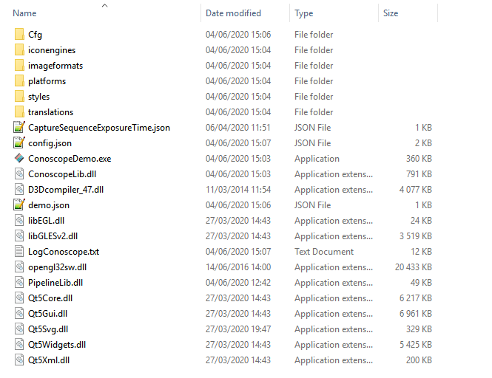

Edit demo.json file and add LogMasks:

{  
 "Application": {  
 "LogMasks": [  
 "State",  
 "StateMachine",  
 "Worker"  
 ],

## Log file

Log files are:

LogConoscope.txt  
LogPipeline.txt